Your ref:
Our ref:
Enquiries: Customer Service Officers

15 May 2020
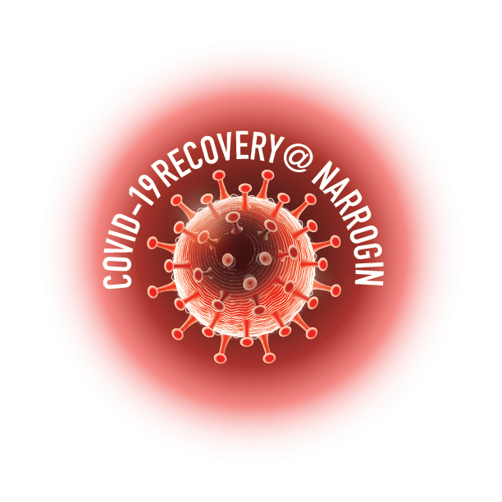

«OtherNames» «Surname»
«Place_Name»
«Street_No» «Street_Name_1» «Street_Name_2» «Street_Name_3»
«Town_State» «Zip»

Dear Narrogin Elector
COVID-19 RECOVERY@ NARROGIN – $50 TO SPEND NOW
TOGETHER WE CAN!
Your Council, together with the Narrogin Chamber of Commerce, sees tremendous value in stimulating our local economy in order to protect our highly valued local businesses in these unusual and difficult times. As a result, your Council has reprioritised some spending within its current Budget.
Commencing 2 June 2020, I request your in-person attendance at the RW (Bob) Farr Memorial Library on Fortune Street, between the hours of 9.00am – 4.30pm, Monday to Friday, so that you may collect your allocation of Recovery@Narrogin Dollars in the form of five $10 vouchers, totalling $50.00. Please note that ID, in the form of a driver’s license or similar, will be required.
Should you be infirmed, or for some reason unable to collect your vouchers in person, then special arrangements can be made with our Customer Service Officers via email recovery@narrogin.wa.gov.au or telephone 9890 0900. Please be aware that, as these vouchers are equivalent to cash, they cannot be mailed.
The vouchers are available to all residents and ratepayers of Narrogin, over the age of 18, who are on the WA Electoral Commission’s Residents’ or Owners & Occupiers’ electoral rolls, as at 20 April 2020.
This program runs for a limited time starting 2 June and finishing strictly on 31 August 2020. We have deliberately run this campaign for a short term to give the participating businesses a quick and much needed injection.
Once you collect your vouchers, you can redeem them at more than 100 participating Narrogin Chamber of Commerce member businesses for either merchandise or services. A current list of participating businesses is available here https://www.narroginchamber.com.au/directory/member-businesses/.
Our hope is that you will use local businesses that you believe have been most impacted by the current COVID Pandemic. We want you to spend your vouchers at the business(es) of your choice, and we want you to spend them now. Local businesses are waiting and they need your help NOW!
Vouchers cannot be redeemed for cash with the Shire nor with the participating businesses who will also not be giving change if you spend less than the voucher value. I encourage you to get your vouchers early and spend it now, in order that it will maximise the benefit and stimulation to our local economy and highly valued Narrogin business community.
If you have any questions about this program, please call the Shire Administration on
9890 0900 or email your question to recovery@narrogin.wa.gov.au .
Together we can!
Yours sincerely
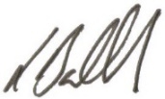

Leigh Ballard
Shire President

